
Department of CSE

B.Tech. CSE Trimester -5

2520030064
Anthony Nissy

Cloud Infrastructure and Services
25CS2206E

LAB RECORD
2026

Experiment -1

AIM: Configure AWS Billing Alerts Using the Custom Budget Option.

Description:
AWS Budgets is a service used to monitor AWS usage and control cloud spending. It allows users to create monthly cost budgets and configure email notifications when spending reaches a specified threshold. This helps users track expenses and avoid unexpected AWS charges.
Procedure / Steps:
Step 1: Log in to AWS Management Console
Open the AWS Management Console.
Enter your AWS account credentials and sign in.
Step 2: Open Billing and Cost Management
Search for Billing and Cost Management in the search bar.
Click the service to open the billing dashboard.
Step 3: Select Budgets
From the left navigation panel, find Budgets and Planning.
Click Budgets to open the AWS Budgets dashboard.
Step 4: Create a Budget
Click the Create budget button.
This opens the page where you can configure a new budget.
Step 5: Select Budget Configuration
Choose Customize (advanced) instead of the simplified template.
Under Budget types, select Cost budget.
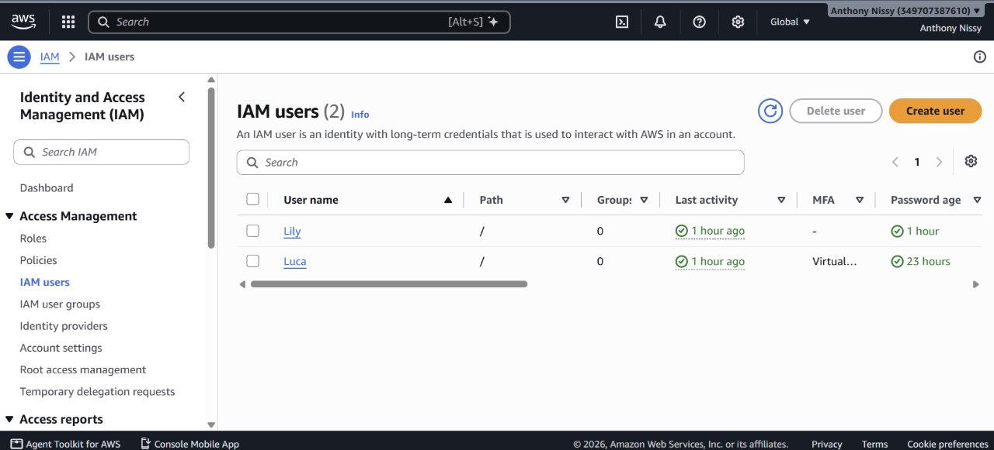
Click Next.
Step 6: Configure Budget Details
Enter the following details:
Field | Value
Budget name | AWS-Monthly-Cost-Budget
Period | Monthly
Budget renewal type | Recurring budget
Start month | Current month
Budgeting method | Fixed
Budgeted amount | $0 (example)
Budget scope | All AWS services
Monthly tracks expenses every month.
Recurring budget automatically renews each month.
Fixed sets a specific spending limit.
All AWS services monitors expenses across AWS services.
Step 7: Configure Advanced Settings
Keep all advanced settings at their default values.
Click Next to continue.
Step 8: Configure Alert Thresholds
Under Configure alerts, click Add an alert threshold.
Enter the following details:
Field | Value
Threshold | 0
Threshold type | % of budgeted amount
Alert trigger | Actual
Email recipients | Your registered email address
Threshold specifies when the alert should be triggered.
Actual monitors the money already spent.
Email recipients specifies where notifications should be sent.
Step 9: Continue to Next Page
Click Next after configuring the alert threshold.
The Attach actions page will appear.
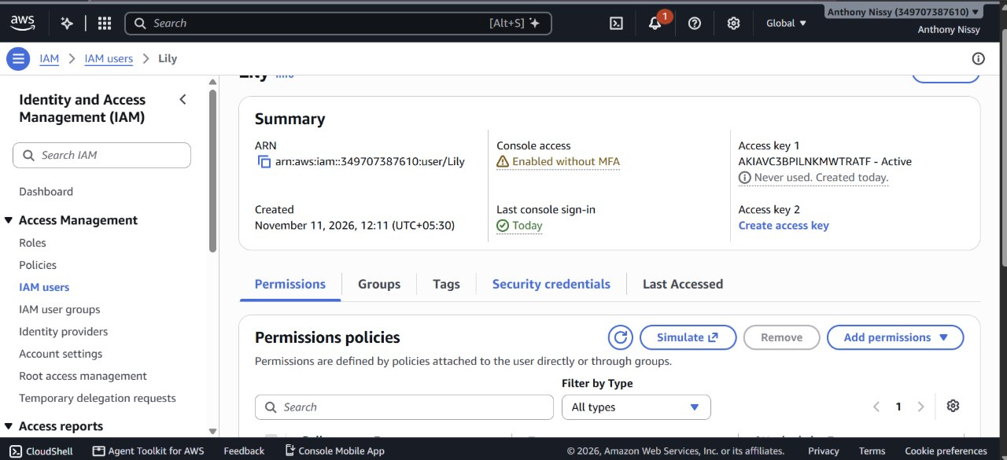
Step 10: Skip Budget Actions
Skip the optional budget actions.
These actions are not required for this experiment because only email notifications are needed.
Click Next.
Step 11: Review Budget Configuration
Check all the entered budget details.
Verify the budget name, amount, period, alert threshold and email address.
Make sure all information is correct.
Step 12: Create Budget
Click Create budget.
AWS creates the budget and saves the configuration.
Step 13: Verify the Budget
Return to the AWS Budgets dashboard.
Check whether A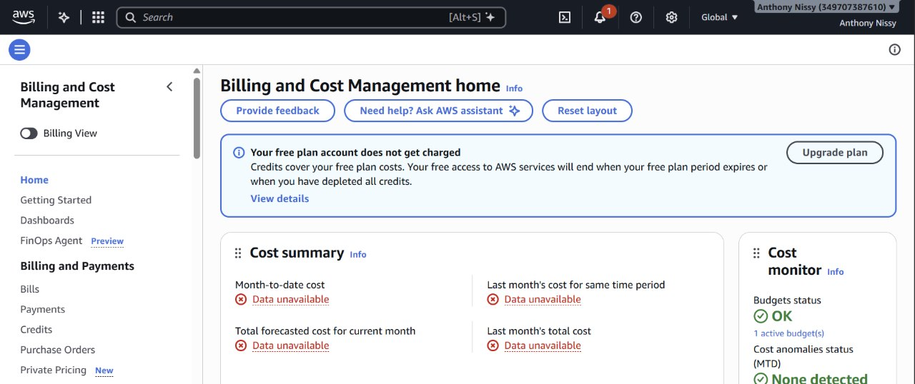WS-Monthly-Cost-Budget appears in the list of budgets.

Step 14: Check Email Notifications
Open your registered email account.
Check for AWS budget notifications.
Verify your email address if AWS requests confirmation.
Result:
Successfully created an AWS monthly cost budget and configured email alerts to monitor AWS spending and receive notifications when the specified budget threshold is reached.
Note: A budget monitors expenses but does not stop AWS services or prevent additional charges. Actual notifications may take time to arrive.

Output:
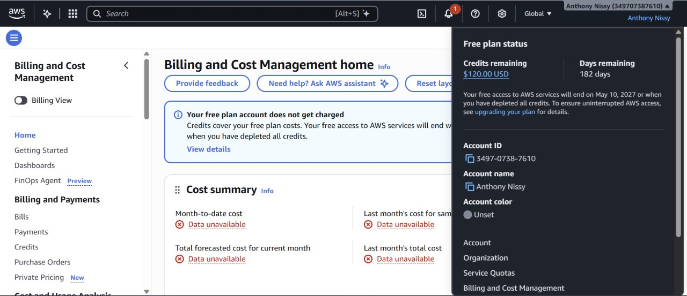
Repeat the same process for IAM user

